ICISF Assisting Individuals in Crisis

Course Description:
Crisis Intervention is NOT psychotherapy; rather, it is a specialized acute emergency mental health intervention which requires specialized training. As physical first aid is to surgery, crisis intervention is to psychotherapy. Thus, crisis intervention is sometimes called “emotional first aid”. This program is designed to teach participants the fundamentals of, and a specific protocol for, individual crisis intervention. This course is designed for anyone who desires to increase their knowledge of individual (one-on-one) crisis intervention techniques in the fields of Business & Industry, Crisis Intervention, Disaster Response, Education, Emergency Services, Employee Assistance, Healthcare, Homeland Security, Mental Health, Military, Spiritual Care, and Traumatic Stress.
Program Highlights
- Psychological crisis and psychological crisis intervention
- Resistance, resiliency, recovery continuum
- Critical incident stress management
- Evidence-based practice
- Basic crisis communication techniques
- Common psychological and behavioral crisis reactions
- Putative and empirically-derived mechanisms
- SAFER-Revised model
- Suicide intervention
- Risks of iatrogenic “harm”
Continuing Education Information
Completion of “Assisting Individuals in Crisis” and receipt of a certificate indicating full attendance (13 Contact Hours) qualifies as a class in ICISF’s Certificate of Specialized Training Program.

ICISF Group Crisis Intervention

Course Description:
Designed to present the core elements of a comprehensive, systematic and multi-component crisis intervention curriculum, the Group Crisis Intervention course will prepare participants to understand a wide range of crisis intervention services. Fundamentals of Critical Incident Stress Management (CISM) will be outlined, and participants will leave with the knowledge and tools to provide several group crisis interventions, specifically demobilizations, defusings and the Critical Incident Stress Debriefing (CISD). The need for appropriate follow-up services and referrals when necessary, will also be discussed.
This course is designed for anyone in the fields of Business & Industry Crisis Intervention, Disaster Response, Education, Emergency Services, Employee Assistance, Healthcare, Homeland Security, Mental Health, Military, Spiritual Care, and Traumatic Stress.
Program Highlights
- Relevant research findings
- Relevant recommendations for practice
- Incident assessment
- Strategic intervention planning
- “Resistance, resilience, recovery” continuum
- Large group crisis interventions
- Small group crisis interventions
- Adverse outcome associated with crisis intervention
- Reducing risks
- Critical Incident Stress Debriefing (CISD)
Completion of “Group Crisis Intervention” and receipt of a certificate indicating full attendance (14 Contact Hours) qualifies as a class in ICISF’s Certificate of Specialized Training Program.
Continuing Education Information
Combined Four-Day Course: 8:30 a.m. – 5:00 p.m.



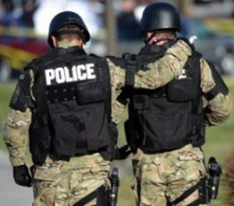

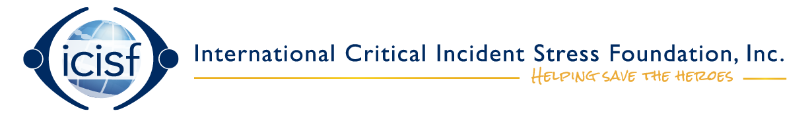

Critical Incident Stress Management Training – Assisting Individuals and Groups in Crisis

October 6-8, 2026

Virginia Law Enforcement Assistance Program is honored to partner with Winchester, Virginia Department of Social Services to host/sponsor an International Critical Incident Stress Foundation (ICISF) Critical Incident Stress Management Training, also known as peer training. The training includes two ICISF courses – the Basic Group Crisis Intervention course and the Assisting Individuals in Crisis course. These courses serve as the training foundation for many organizations with Law Enforcement/Public Safety Peer Support programs. This is also requisite training for peers involved with VALEAP’s CISM Team and is designed for emergency responders in all disciplines. Mental health clinicians who have prior experience working with veterans and/or law enforcement/public safety are encouraged to attend.

***Students must attend all 3 days in order to receive credit for the course.

The typical ICISF registration fee for this course is $525.00, but we are glad to be able to bring it to you at no cost via grant funding and the Southwest Academy Training Foundation.

Registration is capped at 50 participants, and agencies/entities are initially limited to three (3) applicants each. A waiting list will be maintained for additional applicants, and on September 15th unclaimed seats will be made available.

The CISM peer training will be held at Southwest Virginia Criminal Justice Training Academy at 1595 Bonham Road, Bristol VA 24201. Class will be conducted from 8:30 a.m. to 5 p.m. daily.
If you are an interested member of law enforcement, public safety, a chaplain or a mental health clinician, contact Kit Cummings at kitcummings.valeap@gmail.com or (540) 230-9838 or SVCJTA staff at (276) 645-3700 for registration information.

Questions concerning Virginia Law Enforcement Assistance Program or training content may be directed to Kit Cummings at kitcummings.valeap@gmail.com or (540) 230-9838.

