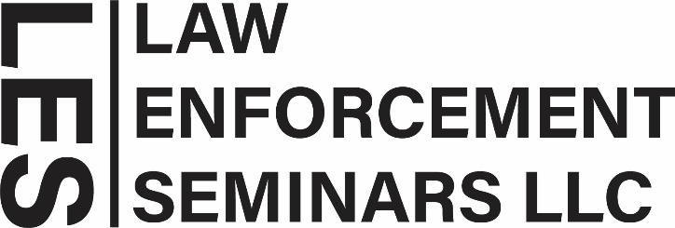
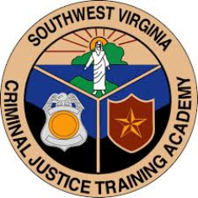
Course Title: Public Safety Wellness
Sponsored By: Southwest Virginia Criminal Justice Training Academy
Length of Course: 12 Hours (1.5-day course)
Date: February 23 & 24, 2026
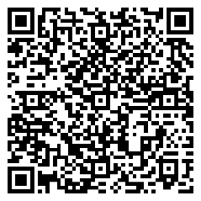
Training Location: Southwest Virginia Criminal Justice
Training Academy
1595 Bonham Rd.
Bristol, Virginia 24201

Training Hours: Day 1 8:00am - 5:00pm
Day 2 8:00am - noon

The physical, mental, and emotional demands of modern-day policing can leave officers feeling frustrated, unappreciated, overworked, and burnt out. This, in turn, leads to more frequent absenteeism, poor job performance, questionable decision making, and disciplinary issues. Participants in this law enforcement-specific course learn the subtle yet severe stressors present in police work that lead to behavioral dysfunction. They are given resiliency strategies, tactics, and information to combat the negative effects of short- and long-term job-related stress. Participants will gain increased awareness and tools to improve their mental, physical, and financial health and to support their career longevity and productivity.

Participants will leave feeling increased engagement in their daily work, a renewed perspective on their career, and with a framework and resources for living a more healthy, balanced, and successful life on and off duty. In this course, you will learn about:

• STRESS & MANAGEMENT • WORK LIFE/HOME LIFE BALANCE
• IMPROVING RELATIONSHIPS • PHYSICAL HEALTH
• FINANCIAL LITERACY • WEALTH BUILDING

REGISTER ONLINE at www.lawenforcementseminars.com

CONTACT: Law Enforcement Seminars Telephone: 469-466-8161
5435 North Garland Avenue
Suite 140-529
Garland, Texas 75040 Email: info@lawenforcementseminars.com

Departmental Contact: Tim Tester
Southwest Virginia Criminal Justice Training Academy
(276) 645-3700 ttester@svcjta.com

